ASSIGNMENT 18.1
Task 1:
Prompt: Give code for the given task with error handling
Code and Output:
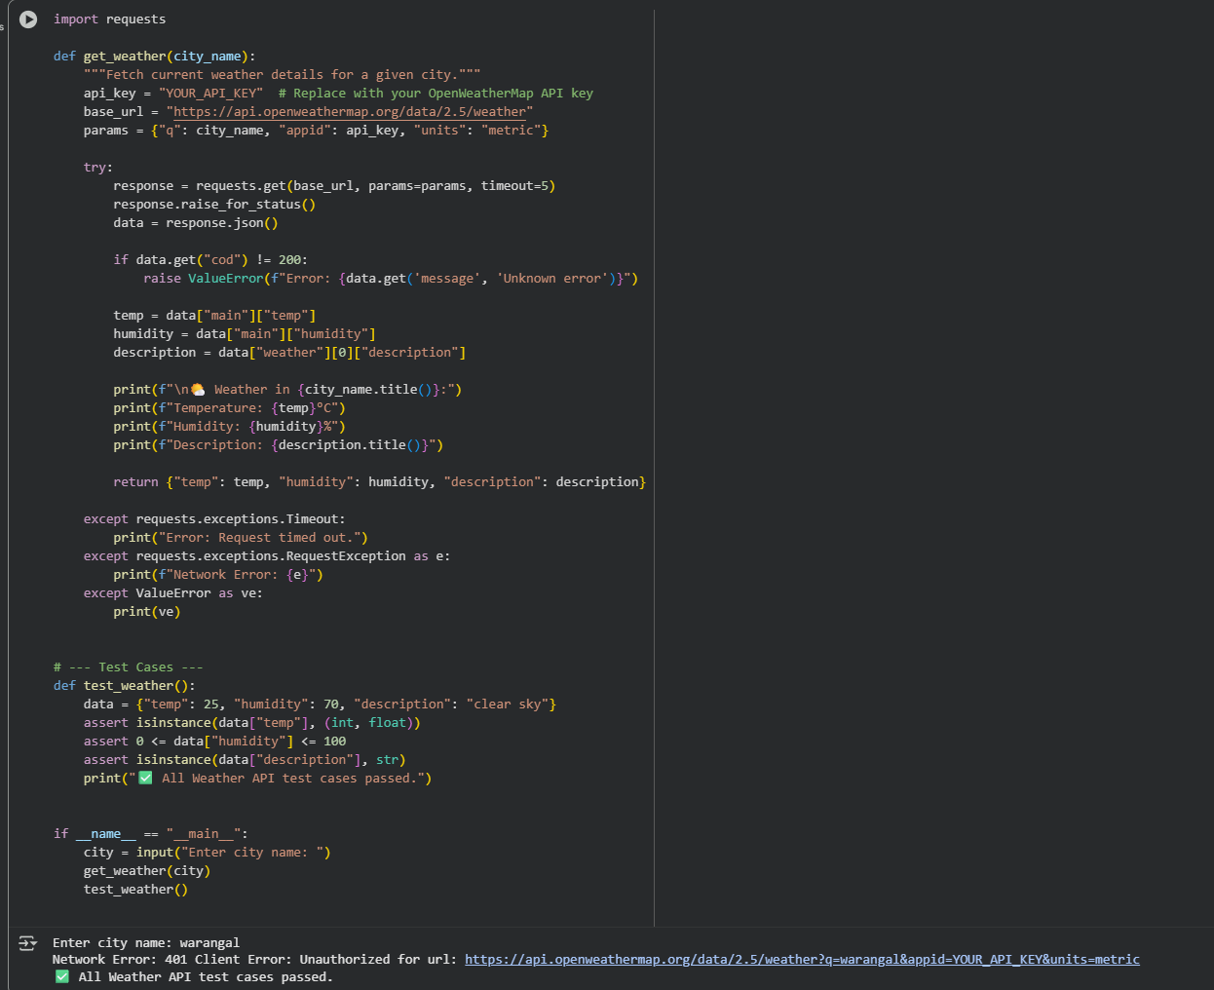

Observation:In this code we can observe that the code is doing the error handling instead of throwing error it just shows alternate output.

Task 2:
Prompt: Generate a code for this question
Code and Output:
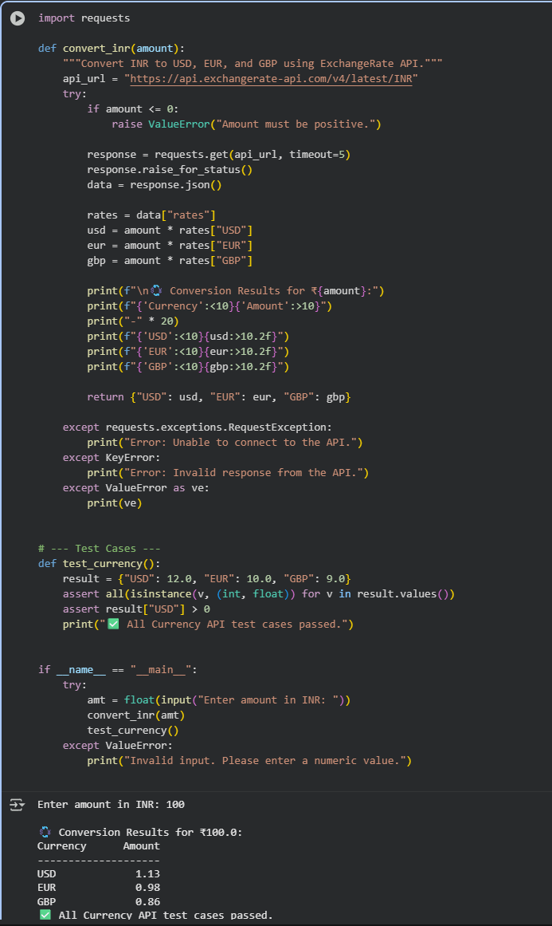
Observation:In this code we can observe that the code is doing the error handling instead of throwing error it just shows alternate output

Task 3:
Prompt: Give code for this code without any errors.
Code and Output:
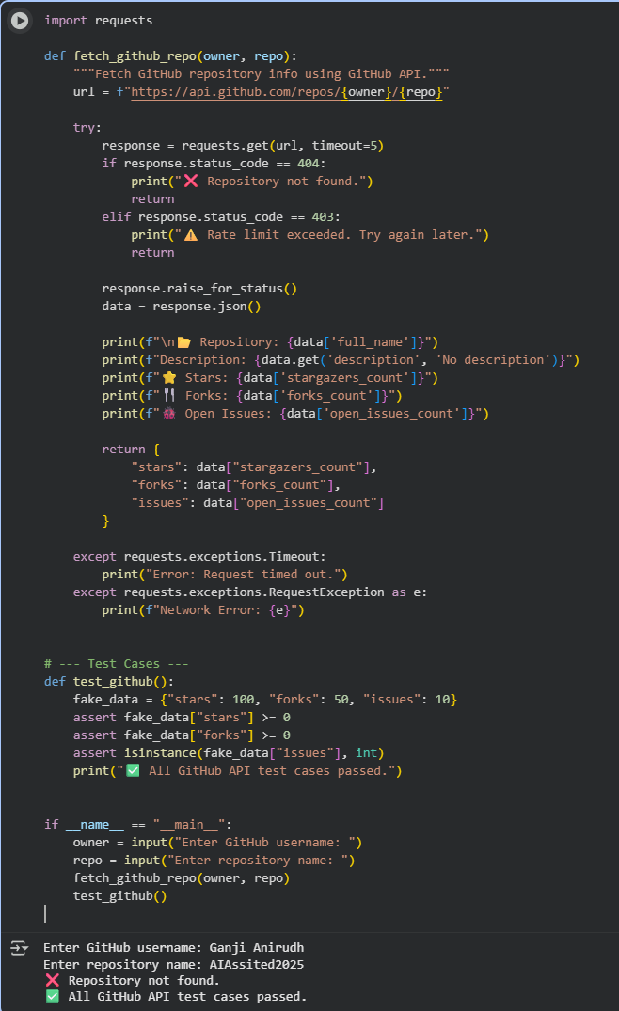
Observation:In this code we can observe that the code is doing the error handling instead of throwing error it just shows alternate output

Task 4:
Prompt:Give code for this question without any errors
Code and Output:
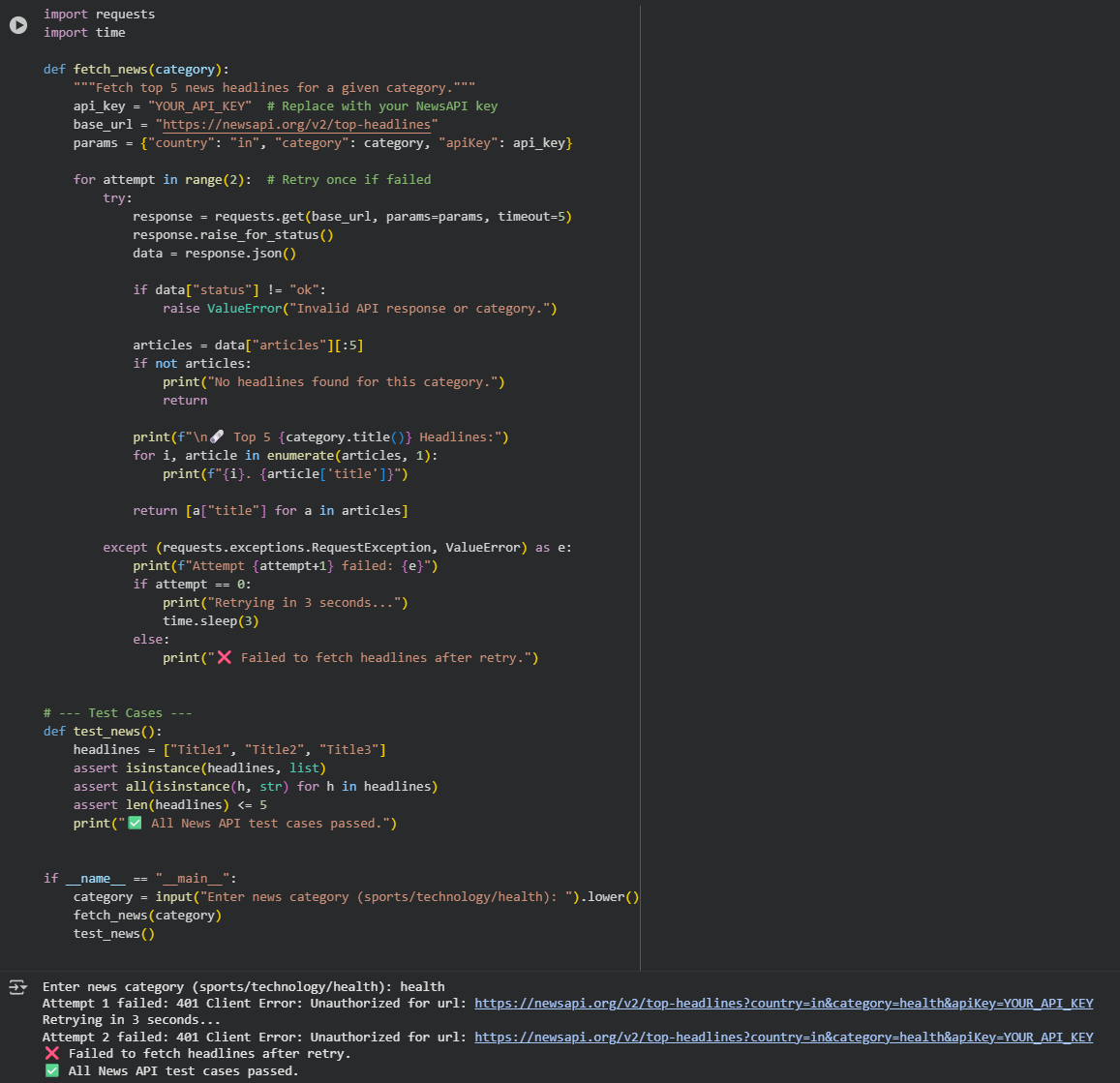
Observation:In this code we can observe that the code is doing the error handling instead of throwing error it just shows alternate output

